

**QUEST INTERNATIONAL UNIVERSITY**

**FACULTY OF COMPUTING AND ENGINEERING**

**Bachelor In Computer Science (Hons)**

**BCS3105 FINAL YEAR PROJECT 1**

**PROJECT TITLE: Biometric Student Attendance Monitoring System**

**PREPARED BY: SAVITHA SAN MARKAN (QIUP-202007-004078)**

**SUBMISSION DATE: 16 JULY 2022**

**Table of Content**

ABSTRACT ……………………………………...

BACKGROUND OF STUDY …………………...

STATEMENT OF PROBLEM …………………..

AIM AND OBJECTIVES ………………………..

SCOPE OF THE STUDY ………………………..

Literature Review ………………………...

SYSTEM ARCHITECTURE DIAGRAM ……….

USE CASE DIAGRAM ………………………….

DATABASE STRUCTURE………………………

PROPOSED SOLUTION ………………………...

SIGNIFICANCE AND BENEFITS ………………

MILESTONES AND DELIVERABLES …………

CONCLUSION ……………………………………

REFERENCES …………………………………….

**1.0 ABSTRACT**

This project focuses on designing and creating a reliable fingerprint-based portable student attendance monitoring system that can be used to track students' attendance. It will get rid of the issues using manual methods. The new method uses a notebook computer as the mobile terminal for processing the photos and recording attendance, and a portable fingerprint scanner as the input to capture fingerprint images. Additionally, a database for storing student data and attendance records is included. Object-oriented programming (JAVA) will be used as the programming language to develop this system.

blob:https://web.whatsapp.com/ab00c9dc-4bfe-4389-8db5-663d016f3a59

**INTRODUCTION**

* 1. **Background of the Study**

Using the traditional method of paper sheets and the outdated file system method, strict attendance management of students in the institution is possible. Every academic institution has requirements for how students' attendance in lectures, labs, and examination rooms should be verified. It is crucial to maintain an accurate attendance record because of this. The method of verifying pupils using paper forms and the previous file system has been in use for years. There are numerous problems with the traditional approach, one of which is the management's inability to compute the percentage of students that attend classes and regularly amend their data.

It can be difficult, time-consuming, and error-prone to manage and monitor student attendance in a school. Biometrics traits can be used to authenticate pupils instead of the more common manual clocking technique that students employ in class or during exams. The development of a biometric student attendance monitoring system based on fingerprints will be the main goal of this study. The fingerprint biometrics are used in this research because they are one of the most widely used biometric applications.

Falsification of student attendance typically occurs when a student signs on behalf of a classmate as being present when this is untrue. This can be particularly challenging to prevent from happening in large classes where row counting can take longer time. Journal of Computer Science and Network Security worldwide (2009).

A person can be identified and verified automatically using biometric technology based on physical characteristics and behavioral characteristics. Because some human body parts are used in biometrics, it is impossible to get lost and a password to be easily guessable may be avoided. Additionally, using biometrics is generally more easy and efficient than using passwords and ID cards when it comes to speed.

The use of a specific person's fingerprint as authentication is analogous to the use of physical data from their body as a password. Utilizing biometric authentication has the advantage of being completely unique to each individual. The same fingerprint cannot exist in two separate persons, it is difficult or impossible for two different people to share the same fingerprint, and fingerprints from various people can never match.

One of the most developed biometric features is the fingerprint, which is recognised in legal proceedings as a reliable form of proof. Worldwide, forensic analysis of fingerprints is used in criminal investigations.

**1.2 Statement of the Problem**

The traditional technique is still mostly used in lecture halls and lab sessions in the majority of schools today. The lecturer or instructor will hand out a sheet of paper with a list of students' names on it for them to sign, or in some cases, it will be the students who write their names, student IDs, and matriculation numbers to signify their attendance for a particular class. The traditional approach is plagued with student attendance fraud. For instance, signing another student's attendance would be straightforward for one student to do. In order to prevent this problem, it is necessary to develop an authentication system for students that makes use of fingerprint biometric recognition in order to track and retain each student's attendance in a particular class. In comparison to using a barcode in smart cards, fingerprints are an individual characteristic for each person. The system developed for this project is not dependent on the present barcode technology as a result of this. Monitoring and tracking student attendance could be difficult, time-consuming, and more error-prone.

* 1. **Aim and Objectives**

The study's aim is to build and create a student attendance monitoring system based on fingerprints that is dependable, scalable, and economical. The following goals are to be met in order to do this:

(i) To conduct an analysis of the manual procedures used to track attendance for classes and exams.

(ii) To design a new biometric attendance system.

(iii) To implement new biometric system using object-oriented programming to implement the design (JAVA)

**1.4 Scope of the Study**

The goal of this effort is to create a fingerprint-based student attendance monitoring system that will simplify the process of managing attendance by authenticating fingerprints as a form of attendance documentation. The system will be a web-based application created using the chosen programming language for creating user interfaces, object-oriented programming (JAVA).

**Literature Review**

CATEGORIES OF ATTENDANCE MANAGEMENT SYSTEM:-

Attendance Management are mainly two types namely;

Default and Standard methods. Typical methods include a attendance muster ,time and timeline. Time cards are data’s, automated or other that documents how long a worker spends on an activity. Attendance muster is a proper inventory of the people who attended the institution or organization. A timeline that is a piece of mechanical (electronic) time are used to detect and track the employee time spend in company.

The default methods include a Barcode system, a magnetic field system, a biometric attendance system and a Radio Frequency Identification (RFID) system.

The barcode program requires that all employees be provided with a badge / card where the barcode is located. To get in and….out of the institution, the id

card is interchanged with a timer, and the information is International Journal for Modern held by the timer. In the existence of magnetic lines, data of the employee is present in the magnetic field card. If the magnetic card is swiping with a timer, the details on the card magnetic field are recorded in time we have swipe. This program has the capacity to read only one magnetic card at once and needs contact from

the student. The Radio-frequency identification system is a type of technique in which transfers data utilising radio waves from an magnetic tag known as an RFID tag which is added to an entity by the program with the motive of recognizing for finding down the entity. The ID cards which are implanted with RFID tags recognized by the student. This RFID program is encrypted in a systems directory. Every worker owns an RFID card and the recognizer datas details that if a worker has left the institution or has entered in it. In this fingerprint Attendance program, there is an existing software matched with a staff timer that needs fingerprint technology for verification purposes. Whenever we utilize this type of system workers can use their impressions of fingerprints to get inside and

outside of the institution. These processes have the significant influence that the whole system is more simple and fast. Other benefits include the removal of pre-existing costs for obtaining employee cards.

Review on Existing System

(Traditional Method)

* Since attendance is a key factor in determining a student's capacity to obtain exam hall tickets and determine their final grade for each semester, tracking student attendance is one of the biggest problems in most schools. Majority of countries divide education into three categories: basic education, secondary education, and postsecondary education. At most schools, use a piece of paper to mark their attendance system That’s how student attendance is manually recorded or tracked. In Malaysia such as Quest International university, a research on the system for documenting student attendance has been done. It has been proved that QIU uses the traditional method to mark their attendance. Monitoring student attendance and absence is time-consuming since it does not involve a system or software. Even human error can lead to incorrect calculations, such as when a student marks his friend attend the class although his friend has skipped class. As a result, it influences students' academic performance. This raises the possibility of using an automated system to monitor and record students' attendance. Therefore, a computerized, automated system for tracking student attendance is needed to help the lecturer and the faculty with this time-consuming task. The following provides a thorough review of a few of the globally used computerized, automated student attendance systems.

Strength

* Low cost

Weakness

* Time consuming
* Traditional method can be easily cheated
* Doesn’t benefit much on monitoring student’s performance

Reviews on Existing System of Fingerprint Scanner used for School Attendance

CR10M RFID Reader

* The CR10MRFID reader is employed in this system. Through radio waves, the RFID reader communicates with the RFID tag and transmits data in digital form to a computer system. A reader includes an RF module that receives radiofrequency signals and transmits them. A host system receives RF emissions from an RFID device and processes them using an RFID reader. The reader is a machine equipped with one or more antennas that send out radio waves and take signals from tags back.

Specifications of CR10M RFID Reader

* Frequency: 13.56 MHZ
* Read Range: Up to 10 cm / Up to 5 cm
* Communication: USB Host
* Operating temperature: - 10˚C to +70˚C
* Power / Current: USB 5V DC/Max. 100mA
* Features: Audible Buzzer, LED Green and Red

ZK 4500 Fingerprint Reader

* The fingerprint scanner that takes the image and the persona computer that simulates the application function and houses the database. Through its USB interface, the fingerprint scanner is linked to the computer. Basically, the creation of hardware is not included in this work. The ZK Finger Software Development Kit (SDK) toolbox, which is supplied by the ZK finger SDK development Guide (will explain the detail), can be used as an interface between the fingerprint reader and the attendance software when using the ZK4500Fingerprint Reader.

Specifications of ZK4500 Fingerprint Reader

* Fingerprint Sensor- ZK4500 optical sensor (no film)
* Resolution- 500 DPI/ 256 gray
* Sensing Area-15 x 8 mm
* Image Size-280 x 360 pixel
* Interface- USB 1.1 / 2.0
* Operating Temperature-0-55. C / 32.-131. F
* Operating Humidity-20%-80%
* USB Cable -150 cm
* Weight – 0.24kg
* Dimension (W x H x D)-53 x 80 x 66 mm
* Automatic Fingerprint Identification
* System (AFIS

Automatic Fingerprint Identification

System (AFIS

Automatic Fingerprint Identification

System (AFIS

Automatic Fingerprint Identification System (AFIS)

The Automatic Fingerprint Identification System (AFISearly )'s algorithms largely attempted to follow the manual fingerprint identification process. For the processing needs and to meet the response time needs, expensive hardware was needed. On a massively parallel system, T. R. Gowrishankar [2] presented a feature-based fingerprint identification approach (architectures with 1000 or more processors). Five features—isolated points, terminating points, merge/branch points, segments, and loops—are taken into account by this automatic fingerprint identification technique as the main components of a feature vector that serve to specifically identify a certain fingerprint pattern. The scanning, recognizing, and coding of fingerprints can be done quickly and cheaply with the technique described by C. A. Gunawardena and V. K. Sagar [4]. Their method uses a median filter to clean the raw fingerprint image, which facilitates edge extraction from the fingerprint.

Strength

* Helps in criminal case
* requires less
* expensive hardware
* using fuzzy logic is that it requires less
* expensive hardwar
* using fuzzy logic is that it requires less
* expensive hardwar
* using fuzzy logic is that it requires less
* expensive hardwar
* Using fuzzy logic that requires less expensive hardware.

Weakness

* Unable to capture the whole of fingerprint image easily
* Smudged furrows and cut ridges in the image of a
* fingerprint are the major problem in the fingerprint
* identification or verification systems
* Smudged furrows and cut ridges in the image of a fingerprint are the major problem in the fingerprint identification or verification systems

Fingerprints Matching Approaches

Taxonomy of the study: There are several methods for matching fingerprints, and these methods can be broadly categorised into three types: correlation-based, minutiae-based, and ridge feature-based methods.

1. Correlation-based: Since rotation and displacement are unknown, correlation-based alignment is applied to potential alignment by matching and computing alternative alignments between the corresponding pixels of two superimposed fingerprint pictures.
2. Minutiae-based: matching finds the tiniest alignment between the fingerprints to determine the greatest degree of similarity.
3. Ridge feature based: is another name for this type of feature-based analysis. This strategy makes use of features that were taken directly from the ridge pattern.

Conclusion- The smart attendance system, which uses a biometric fingerprint technology, is able to monitor student attendance in schools and colleges will be made easier by this technology. Manpower can be reduced by the system. Although there are several ways to track students, our system is incredibly user-friendly and useful for college and university levels. This system offers reliability, time savings, and simple control.

2.0 System Architecture Diagram

When creating the fingerprint-based student attendance monitoring system, a top-down approach was taken. The analysis's findings were divided into many components, with the design process beginning with the primary component and working its way down to the most basic ones. The System was divided into three (3) major subsystems, namely the student, lecturer, and admin subsystems. Users have varying levels of system access privileges for each of the aforementioned subsystems.

The user of the admin subsystem has the ability to add, delete, and update all of the system's data and information. This subsystem is further divided into the following components: add Course, assign Course, enrol Student, enrol Lecturer, enrol Student using Fingerprint, and Report. The administrator can remove, add, and update subsystem data in the subsystems that are listed.

The user can only activate attendance, see a student record, mark attendance, and select the courses they were assigned to lecture on, unlike the admin subsystem where most capabilities are removed. A further breakdown of the subsystem includes (I) course, (II) lectures attended, (III) activation period, and (IV) profile.



















Figure 2.1: Design approach for the system

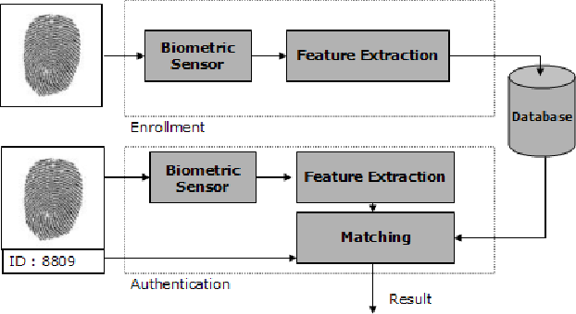



**Figure 2.2 an overview of the System Architecture Design**

**3.0 PROPOSED SOLUTION**

**Existing System**

Regular attendance will not only necessarily guarantee exposure to the range of majors and possibilities available at the institution, but it is also one of the elements used to determine your final grade. Attendance is a significant factor in educational institutions. Colleges and universities may find it tiresome, time-consuming, and more mistake to track and monitor student time of attendance through manual attendance. Due to some students' ability to copy other students' signatures, the manual signature-based attendance system used in classrooms is not very trustworthy.

The most frequent issue with manual attendance signing is that the lecturer must physically fill out an attendance sheet or book for each session, which really takes a lot of time and tiresome.

As an example. Quest International University Perak uses a manual system during F2F class where students are required to sign their attendance, which can be easily forgery by the student who is absence. The particular student who didn’t attend the class may ask her friend who attended the class to mark her attendance. Even in the QIU website, the student can easily enter the password to mark their attendance though they’re not in the google meet/zoom class.

**New System**

The new system will address the limitations of the old system by maintaining historical data that makes it simple for lecturers to access and evaluate students and by offering a high level of security that prevents imposters and impersonators from entering exam rooms. The method will enable the professor to keep track of each student's attendance, identify truants, and take appropriate punishment. It also lessens the management uses with queuing up, which frequently causes delays and damages attendance records. Hence, in QIUP student have to compulsorily attend the class physically to mark their attendance using the fingerprint scanner and it can’t be forgery. The new system will include an easy user interface that will assist everyone user, including those without specialist training, to operate it appropriately. The picture below is the fingerprint scanner.

blob:https://web.whatsapp.com/3b35e496-d49f-4fb7-8033-01bdaf3fc433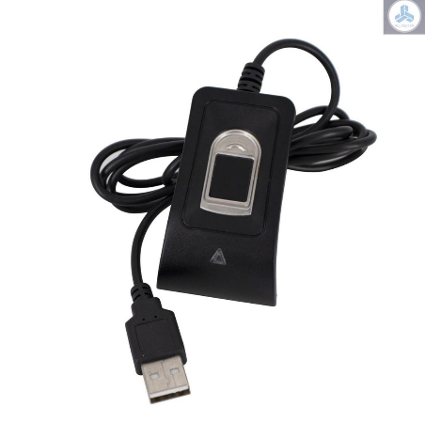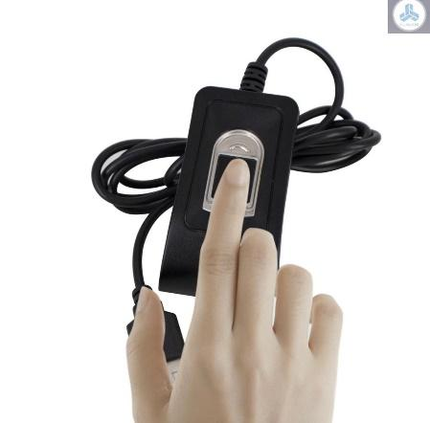

**3.1** **The Proposed New System**













No



Yes



Yes No 

Yes

Yes



No 

Yes



No

Yes



Fig 3.1 Flow Chart for User Start Page

Figure 3.1 showed the User Start page the new system in a flowchart format. The User Start page is used as the landing page of the system then and each user base on their role will select the module they have the privilege to access.











Yes

No

Yes

No

Yes 

No

Yes

No





Yes

No

Yes 



No

Yes





Fig 3.2 Flow Chart for Admin Sub Program

Figure 3.2 represents the admin sub-system. Here is where users who logged in as admin are redirected to. The user of this sub-system maintains the entire system by performing actions such as; enrolling lecturers and students, assigning courses to lecturers and change password etc.













No 













Fig 3.3 Flow Chart for Student Sub Program

Figure 3.3 represents the student sub-system. Here is where users which are the student take their attendance for a particular class after the lecturer must have activated it with the duration of time the lecturer wants the attendance marking to last.

**4.0 Use Case Diagram for Attendance Fingerprint Scanner** 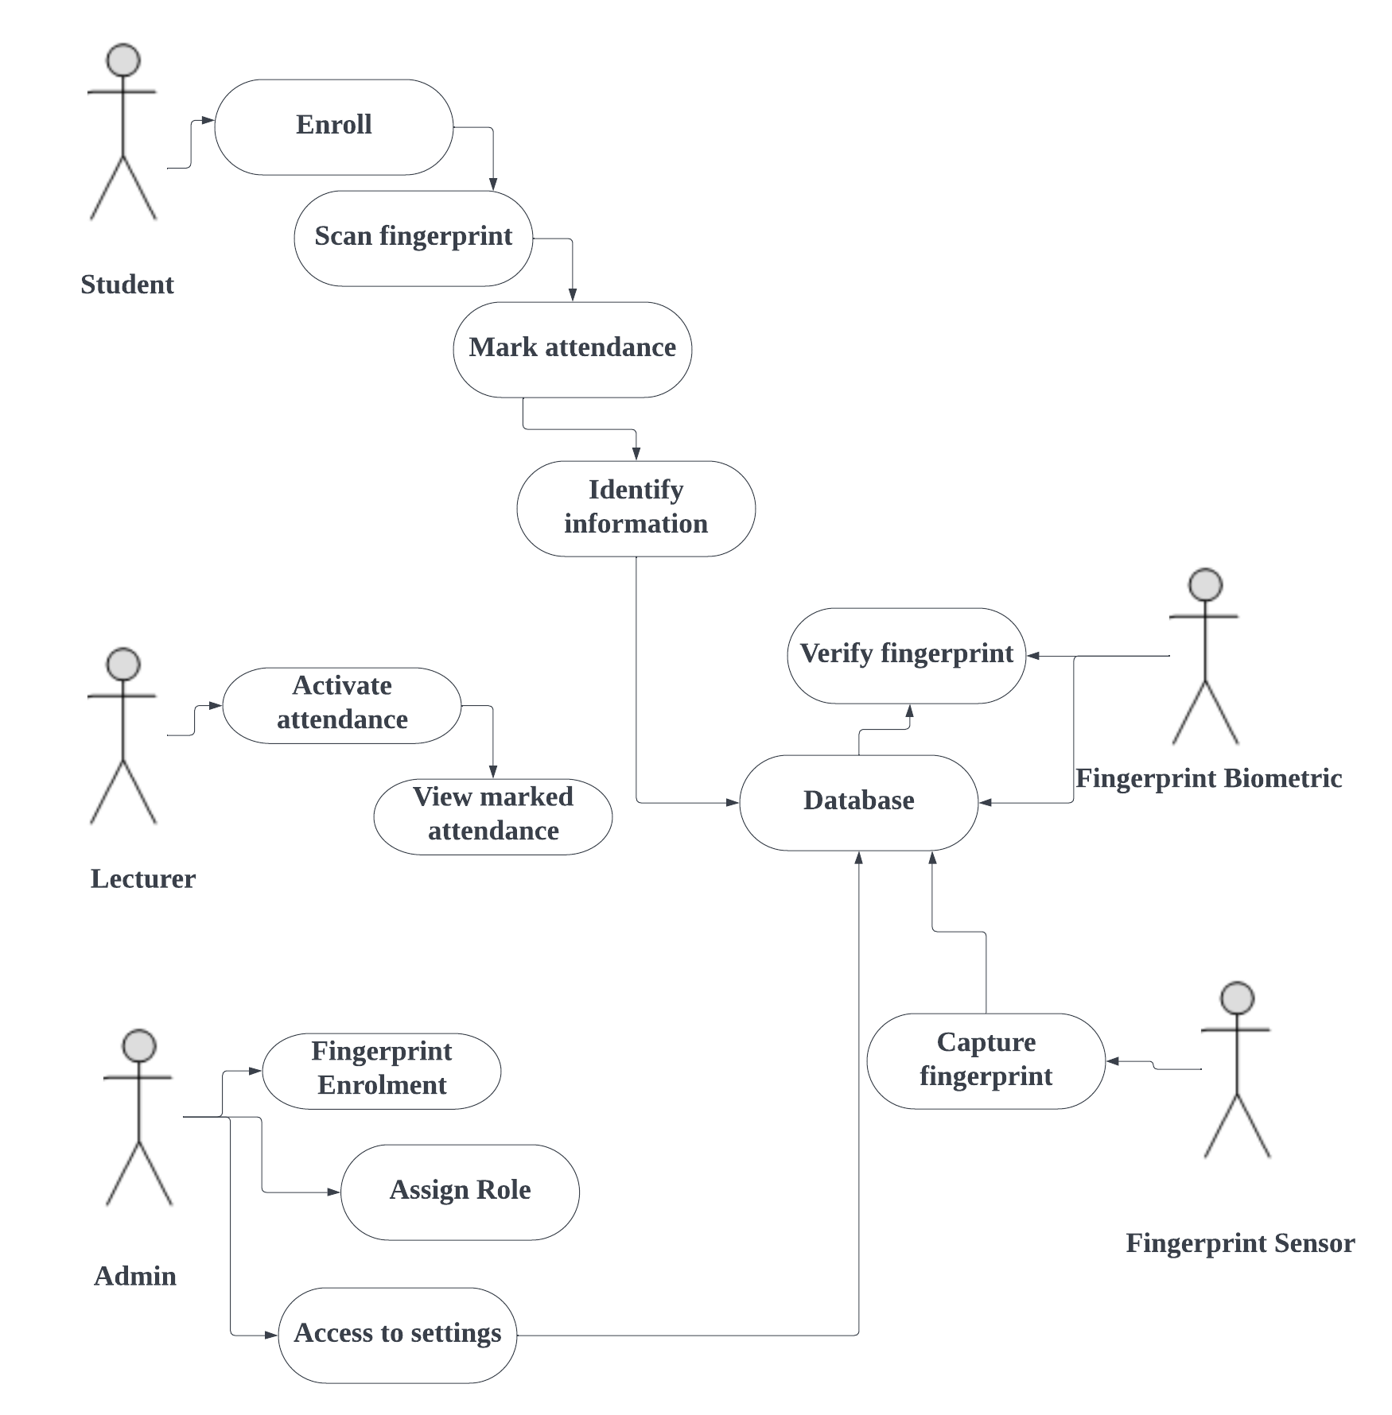

**5.0 Database Structure**

**Administrator database**

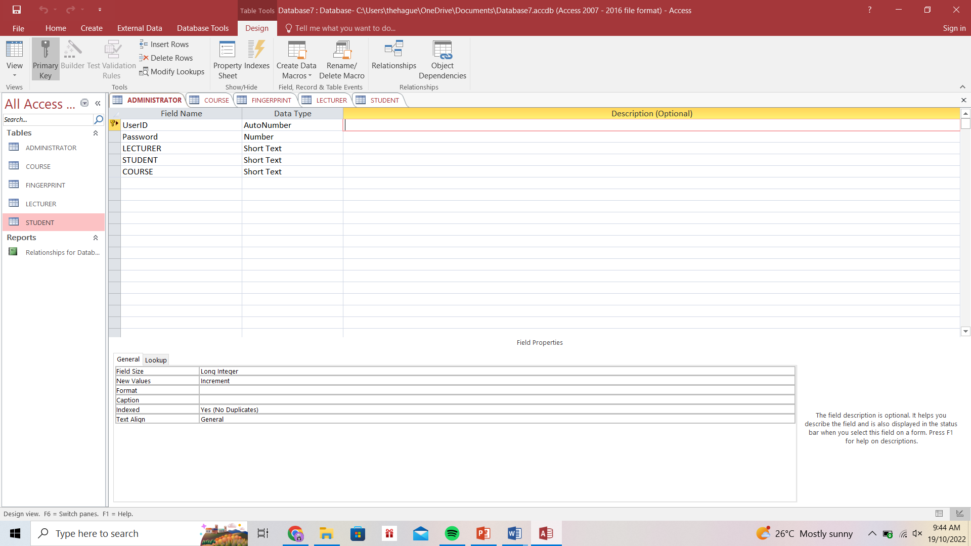

Table structure of admin database. Admin’s personal records are stored and access.

**Course database**

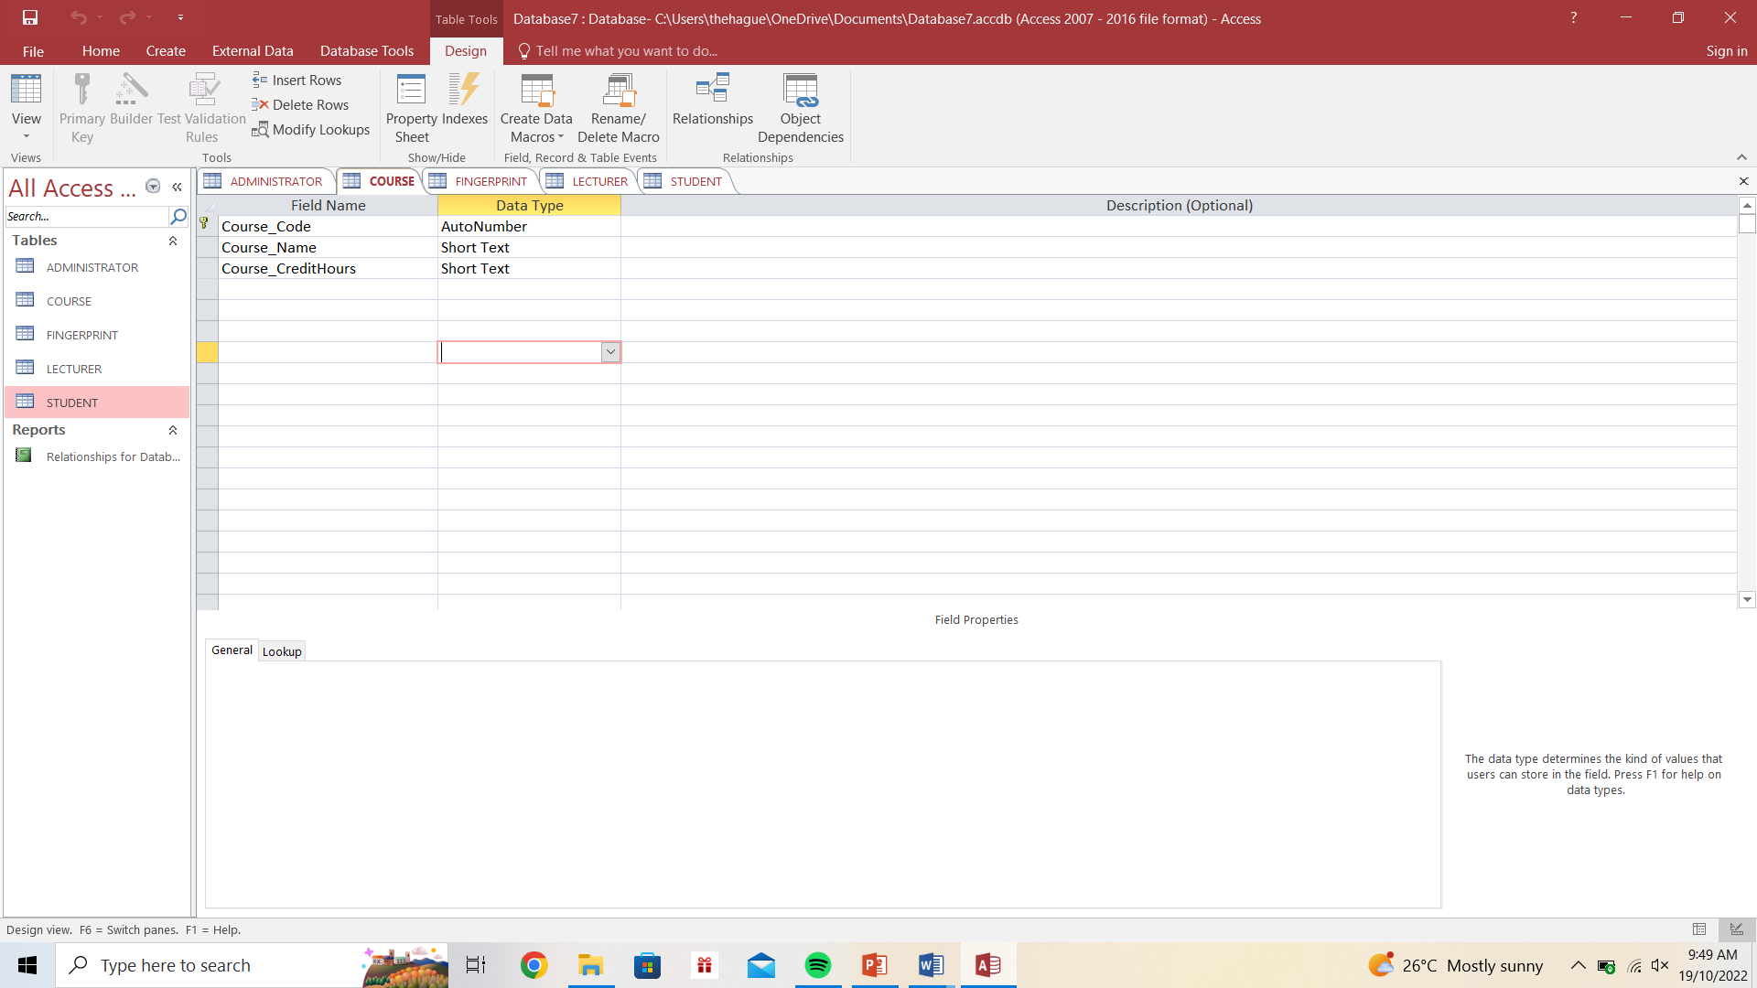

Table structure of course database. All courses that students are to offer and take attendance are stored and accessed here. The courses sub-system uses this database to manage courses.

**Lecturer database**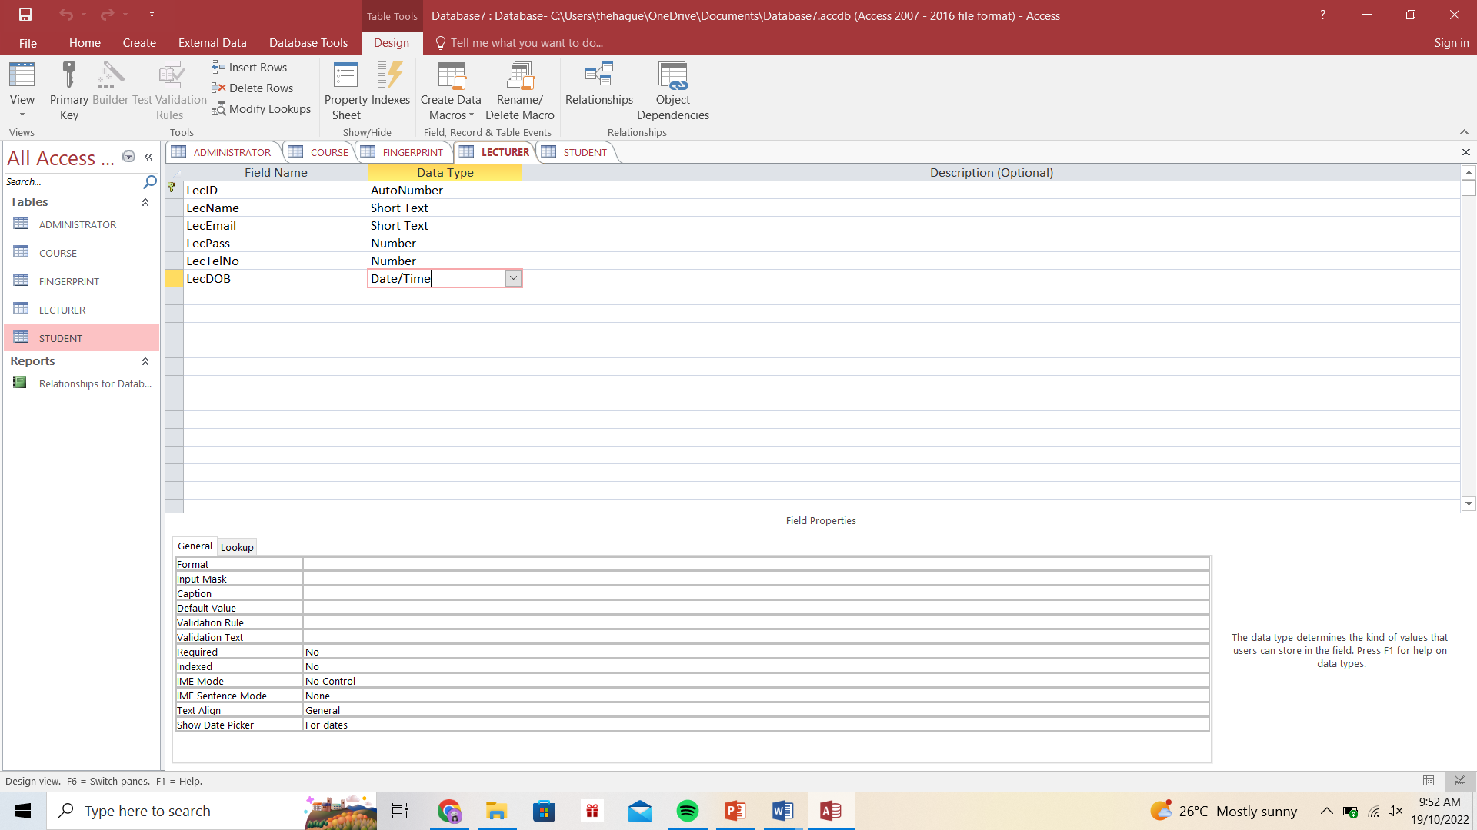

Table structure of lecturer database. The lecturer database is where the information needed from a particular lecturer. This database is only accessed by view lecturer sub-system.

**Student database**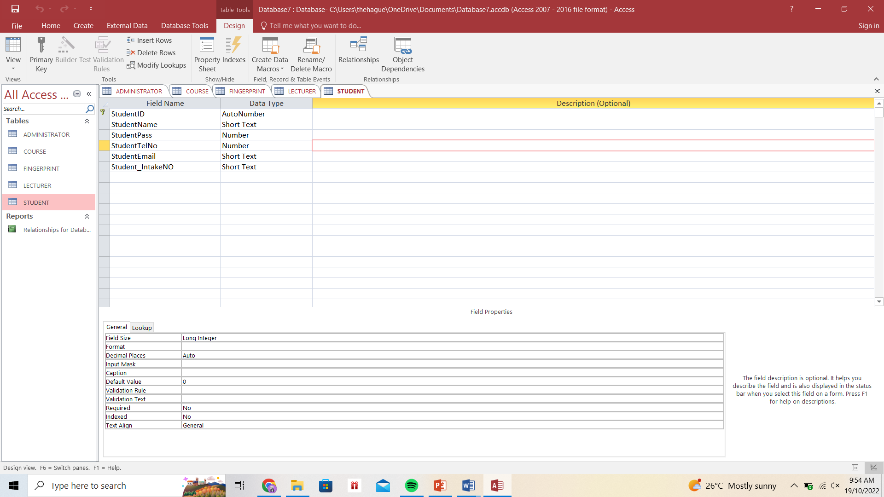

Table structure of student database. The student database is where the information needed from all students is stored and accessed by the administrator for updates.

**Fingerprint Database**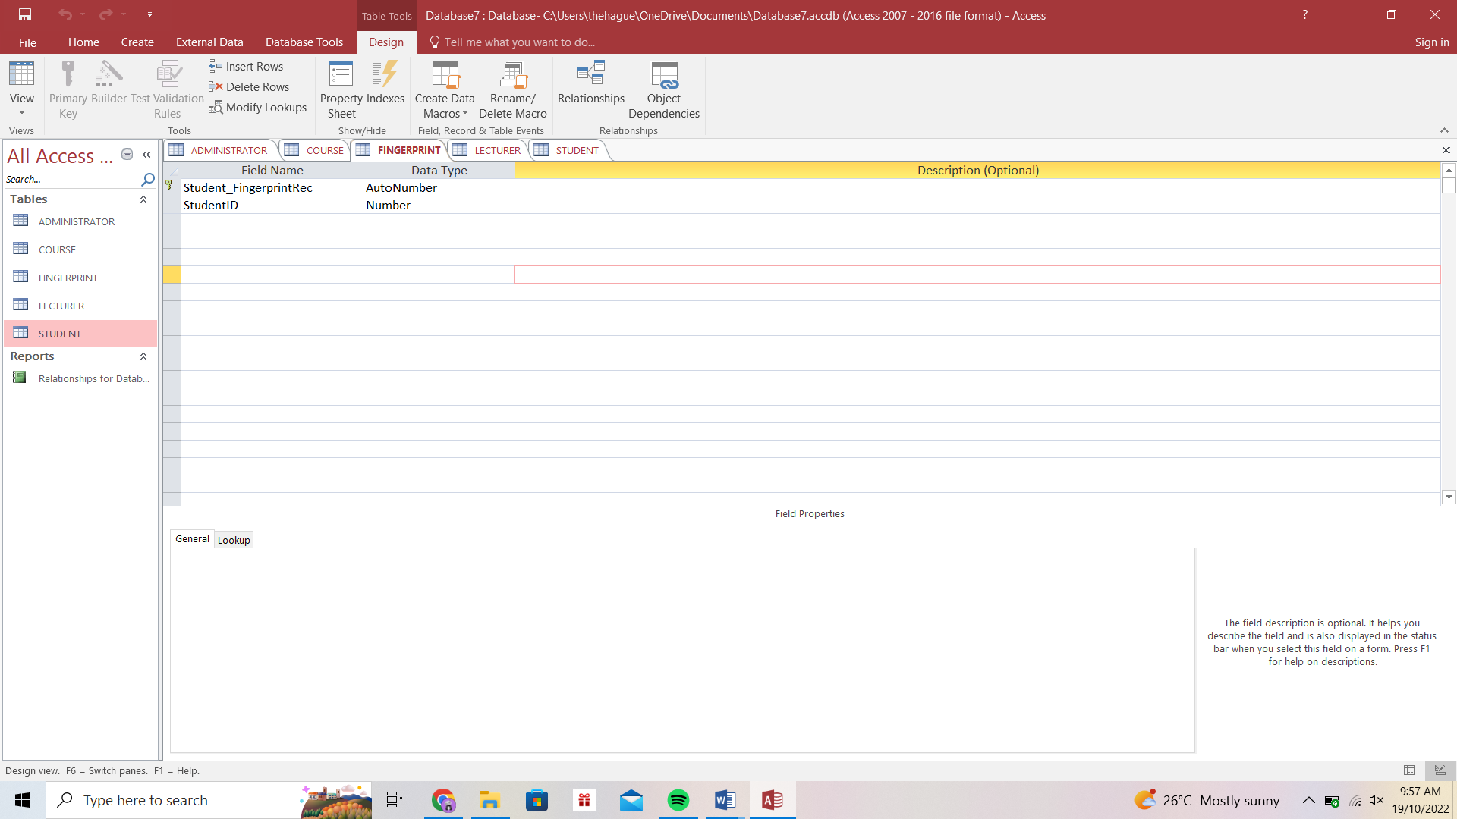

Table Structure contains details of student’s fingerprint pattern and also student’s personal information.

**5.1 ENTITIY RELATIONSHIP DIAGRAM**

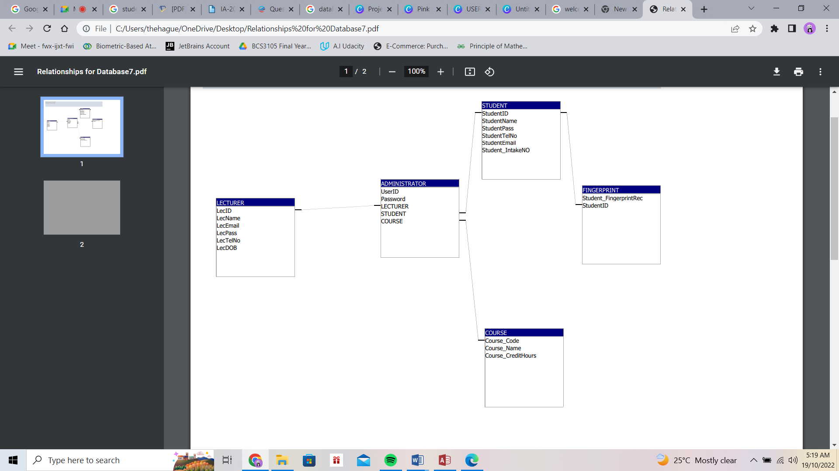

**Activity Diagram**

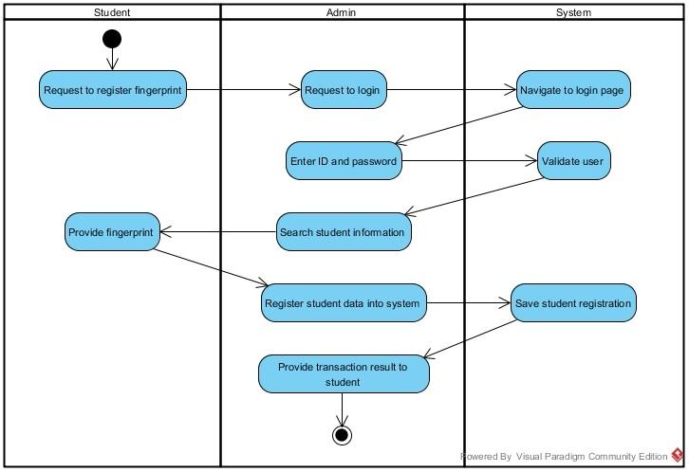

**Activity Diagram for Register Fingerprint (Student)**

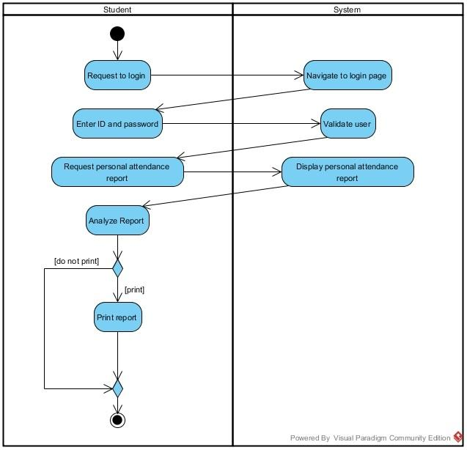

**Activity Diagram for Keep Track of Student’s Personal Attendance Record**

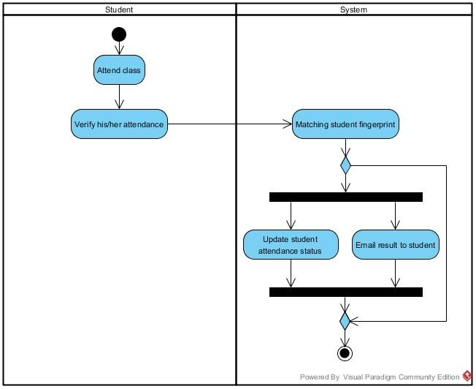

**Activity Diagram for Check-in Attendance (Student)**

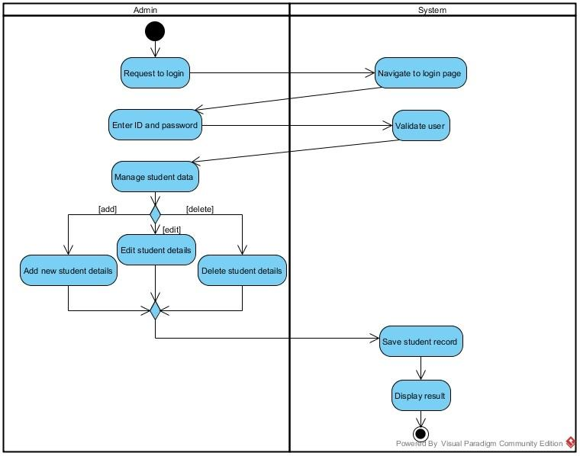

**Activity Diagram for Manage Student Information (Admin)**

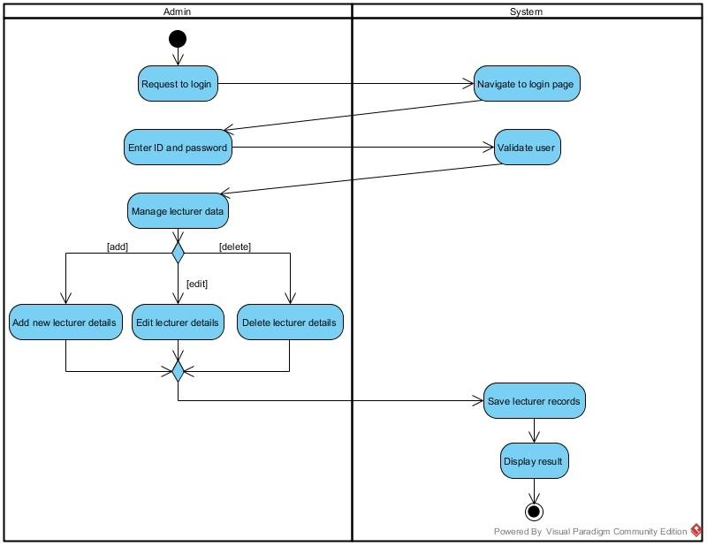

**Activity Diagram for Manage Lecturer Information (Admin)**

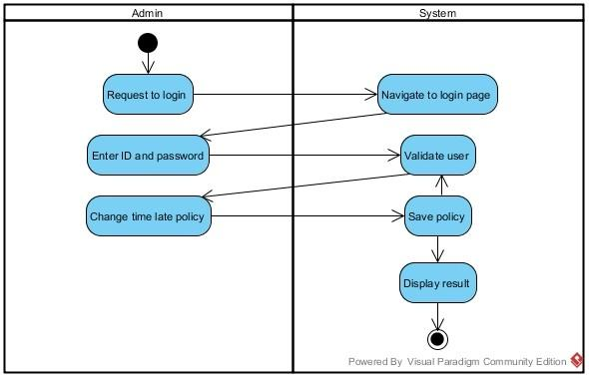

**Activity Diagram for Manage Time Late Policy (Admin)**

**6.0 Significance and Benefits**

The System for Students using fingerprint Biometric will eliminate the use of paper in manual signing processes and all the risk associated with it. One of the risks of using a paper in class attendance is that it can be easily misplaced and students cheat by signing for each other not present in the class thereby defeating the aim of taking the attendance. Tracking and monitoring students time of attendance could be tedious, time consuming and susceptible to error. Thus, the System will drastically reduce time needed to verify attendance data.

**7.0 Milestone & Deliverables**

| **Milestone** | **Date** | **Action Required (AR) by Supervisor / Student /**  **Moderator** |
| --- | --- | --- |
| Registration | Two Weeks Before  Week 1 | Student AR:   * Identify area of interest and look for potential supervisors. * Suggest a project title. * Submit title registration form. Supervisor AR: * Hold discussion sessions with students. * Prepare project titles. |
| Submission of Proposal | One Week  Before Week 1 | Student AR:   * Submit project proposal. FYP Committee AR: * Evaluate the titles. * Students who do not have a project title will be assigned to a supervisor and a title. |
| Proposal defence | Week 1 and Week 2 | Student AR:   * Present proposal to FYP committees.   FYP Committee AR:   * Evaluate the proposal * Give endorsement whether to proceed with the proposed title or make changes. |
| Biweekly meeting and Mid Term Assessment | Progress Report:  Week 2, 4, 6,  8, 10, 12 | Student AR:   * Meet with supervisor at least once per week / biweekly as determined by the supervisor. * Submit a progress report. Supervisor AR: * Verify and sign on the progress report. * Supervisors to keep the verified reports. |
| Submission of project  Interim Report or Final Report | Friday  Week 12 | Student AR:   * Submit 2 sets of Interim Report to supervisor. Supervisor AR: * Mark interim report. Results are handed in to the FYP Committee. Moderator AR: * Review report. Get some idea of student’s project before student’s presentation. |
| Oral Presentation or Final Presentation | Week 13 and Week 14 | Student AR:   * Present project in public.   Supervisor AR and Moderator AR:   * Assessment by moderator and expert panels. |
| Moderation (if necessary) | Week 15 | Supervisor, Moderator and Expert Panel AR:  • Attend Deliberation Meeting |
| Submission of Hard Bound Report with CD | Week 16 | Student AR:   * Prepare Hard Bound Final Report * Burn CD (2 sets) to be submitted with the Report and Project Submission Form. |

**SYSTEM IMPLEMENTATION, TESTING AND INTEGRATION**

**Choice of Programming Language**

* Java Spring Boot- Spring Boot is an open source Java-based framework. Spring Boot provides a good platform for Java developers to develop a stand alone and production-grade spring application that you can just run. You can get started with minimum configurations without the need for an entire Spring configuration setup. The reason for using this language is because it easy to understand and reduces the development time.

Spring boot provides a flexible way to configure Java Beans, XML configurations, and Database Transactions. Spring Boot, everything is auto configured; no manual configurations are needed.

* Microsoft SQL Serve- MSSQL server is used to implement the back end of the new system. The server uses relational database management system that offers a variety of administrative tools to ease the burdens of database development, maintenance and administrations. It also allows the use of stored procedure which is used to implement some of the business logic directly from the database.

How would the following programming languages work together;-

* Spring Boot automatically configures your application based on the dependencies you have added to the project by using @EnableAutoConfiguration annotation. For example, if MySQL database is on your classpath, but you have not configured any database connection, then Spring Boot auto-configures an in-memory database.

**FINGERPRINT ATTENDANCE SYSTEM GUI**

The System Main Menu Implementation

This refers to how the main menu in the system is being implemented. There are several interfaces that make up the entire system. They are described below:

Main Menu

Figure -- shows the administrator login, lecturer activator setup and student attendant manager. Here the administrator can login by clicking on the Admin login and then proceeds to other settings or updates, settings in terms of inputting of administrator username and password. The lecturer and students so also can proceed to other action by clicking on their various options on the main menu.

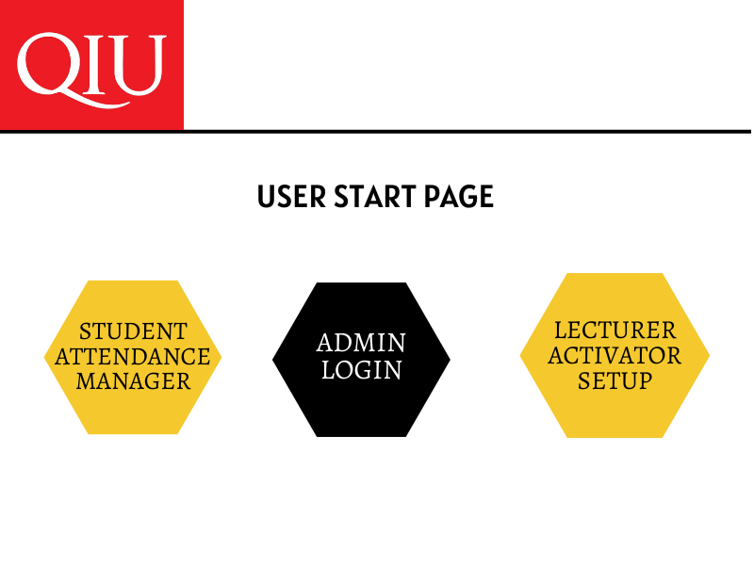

USER START PAGE

**8.0 Admin Login Page**

Figure 8.0 shows the login page of administrator. The administrator types in his/her user name and password in order for them to navigate to the main page where he/she to perform enrolment, updates and settings.

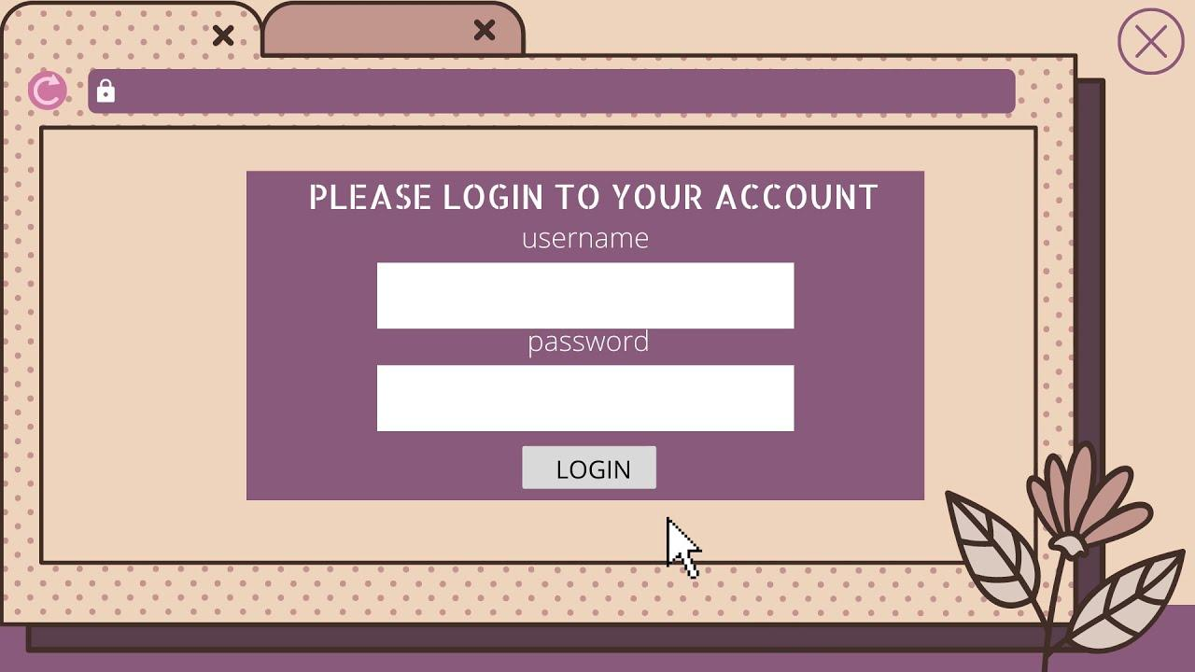

**Admin Login Implementation**

**8.1 Lecturer Activator Setup Page**

Figure 8.1 shows the attendance activator for the lecturer in any particular class. The lecturer will have to login, input fingerprint for verification and activate a particular session of class and the duration of time it will take for the attendance marking session of the student. Students cannot take attendance without the lecturer activating.

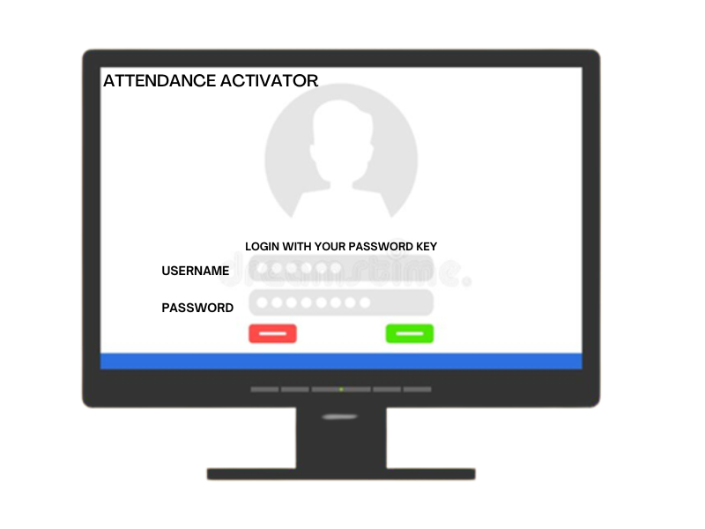

**Lecturer Activator Setup Page**

**8.2 Implementation of the Sub-system**

Selecting the administrator (Admin) login option from the main menu results in a display of Login form, after providing a valid username and password, access is then granted to the administrator who can also be the lecturer, which then leads to the administrator sub-menu, which have the file menu, settings menu, setup menu and report menu. The administrator can enroll fingerprint of the lecturers and students, change password etc from the settings menu in the administrator’s sub-menu.

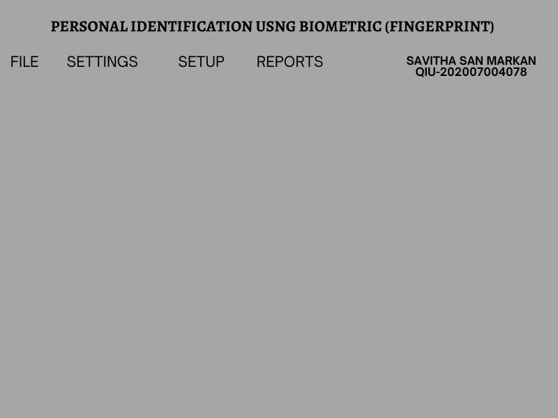

**Administrator Sub-menu**

**8.2.1 Student Enrolment submenu**

In figure 8.2.1, the students are being enrolled by the administrator or lecturer. The student’s bio data is being registered and the fingerprint of each student is been captured for authentication of the attendance.

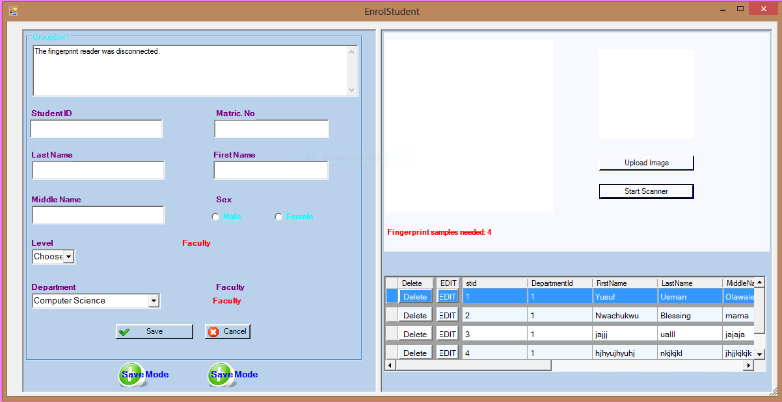

**Student Enrolment submenu**

**8.2.2 Lecturer attendance activator**

Figure 8.2.2, the lecturer activates the system for each session before student marks attendance. The lecturer inputs his/her course for the session and the duration for the attendance marking

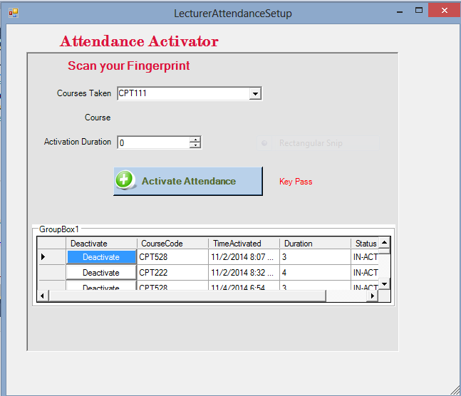

**Lecturer attendance activator**

**8.2.3 Student fingerprint verified**

The 8.2.3 shows the fingerprint verified of the student for a particular session of class. At this time the duration time that the lecturer set is still on, if any student comes after the duration time the attendance manager shows session not activated.

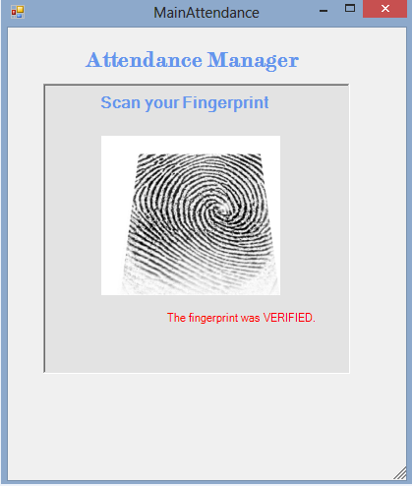

**Student fingerprint verified**

**8.3 Query Sub-System Implementation.**

The MSSQL Server which setup the relational database of is very important because it provides the authentication system with efficiency, consistency and reliability. However, after the administrator must have input the information’s of all the students for a particular session, the administrator can therefore query a particular department to know how many student is in that particular department from the database and also how many students had been enrolled and authenticated for a particular course. The lecturer can also query the attendance update from the database to know how many students were present in class for a particular lecturer in order to assign marks for attendance to the present students.

**8.4 System Testing and Integration**

This is a formal process of soliciting feedback on or from a system that is being developed. It is used to determine the effectiveness, the correctness, efficiency, reliability and robustness of the proposed system. Unit testing will be carried out on individual components of different layers in the application to verify and ensure all different components such as classes are at the required minimal functional level. Also, integration test shall also be carried out when after building system, where all the independent components or modules are then integrated together to further verify the functionality of the interfaces of each components so as to spot defects in various interfaces and the behaviour or responsiveness of each components when interacting together.

**8.5 Test Plan**

It involves a stage-by-stage assessment of all the subsystems which are carried out to determine the performance and efficiency on the authentication system and comparing the result to the over-all desired result. Test plan is carried out to verifies that the system elements have been properly integrated.

**8.6 Test Data**

The data needed for the testing comprises of all student information such as student ID, mat no, name and email. The lecturer personal information such as staff ID, name and phone number which is to be filled when administrator is enrolling students or lecturers. The course details so also such as course code, course title, and course unit which is to be filled by administrator after the students and the lecturers have been rolled and authenticated.

**9.0 Conclusion**

It can be concluded from the above report that a reliable, secure, fast and an efficient system can be developed replacing a manual and unreliable system. Variety sources have shown that this system can be implemented in academic institutes for better results regarding the management of attendance. This system will save time, reduce the amount of work the administration has to do and will replace the stationery material with electronic apparatus. Hence a system with expected results will be developed by me and I will ensure to utilize, extended and implemented ideas in the areas of error corrected string construction from biometric data, key generation, and pairing based fingerprint schemes to form the components of the system. This report has been an insight into the hidden problems; the manual attendance system tends within daily activities. The problems are fair and need computerized authentication system to replace the manual student attendance system.

**References**

1. N Zakiah Lamin et al 2021 IOP Conf. Ser.: Mater. Sci. Eng. 1062 012037

<https://iopscience.iop.org/article/10.1088/1757-899X/1062/1/012037/pdf>

1. Hernandez-de-Menendez, M., Morales-Menendez, R., Escobar, C.A. *et al.* Biometric applications in education. *Int J Interact Des Manuf* **15,**365–380 (2021).

<https://doi.org/10.1007/s12008-021-00760-6>

1. TY - JOUR AU - Alhothaily, Mohammed AU - Alradaey, Mohammed AU - Oqbah, Mohammed AU - El-Kustaban, Amin PY - 2015/06/01 SP - 34 EP - 44 T1 - Fingerprint Attendance System for Educational Institutes VL - 20 DO - 10.20428/JST.20.1.4 JO - Journal of Science and Technology ER -

<https://www.researchgate.net/publication/304216847_Fingerprint_Attendance_System_for_Educational_Institutes>

1. TY - JOUR A2 - Marletta, Vincenzo AU - Hoo, Seng Chun AU - Ibrahim, Haidi PY - 2019 DA - 2019/09/15 TI - Biometric-Based Attendance Tracking System for Education Sectors: A Literature Survey on Hardware Requirements SP - 7410478 VL - 2019

<https://doi.org/10.1155/2019/7410478>

1. Edmund O . Mati Jr. Information Systems, Computer Science, Software Engineering, Human Computer Interaction, Computer Engineering, Web Design, Database Systems, Databases

<https://www.academia.edu/7760318/STUDENTS_ATTENDANCE_MANAGEMENT_SYSTEM_MINI_PROJECT_REPORT_MASTER_OF_COMPUTER_APPLICATIONS>

1. Marcela Hernandez-de-Menendez, Ruben Morales-Menendez, Carlos A. Escobar & Jorge Arinez International Journal on Interactive Design and Manufacturing (IJIDeM) volume 15, pages365–380 (2021)

<https://link.springer.com/article/10.1007/s12008-021-00760-6>

1. Singh, Manmohan & Sharma, Vivek & Arora, Ajat. (2005). Fingerprint Identification: A Literature Review.

<https://www.researchgate.net/publication/355488756_Fingerprint_Identification_A_Literature_Review>